**Bug Report For the Project:**

**GOMYCODE**

|  |  |  |
| --- | --- | --- |
|  | **General information** |  |
|  |  |  |
| **Customer** | **GOMYCODE PROJECT** |  |
|  |  |  |
| **Created by (Author)** | **Godwin Udofia** |  |
|  |  |  |
| **Preparation date** | **28/3/2025** |  |
|  |  |  |
| **Version** | **1.0** |  |
|  |  |  |
| **Status** | **Defects** |  |
|  |  |  |

**Revision History**

|  |  |  |  |  |  |  |  |  |
| --- | --- | --- | --- | --- | --- | --- | --- | --- |
| **Version** | **Description** | **Author** | **Date** |  | **Approved by** | |  |  |
| **Author** |  | **Date** |  |  |
|  |  |  |  |  |  |  |
| **1.0** | **Defect Log** | **Godwin Udofia** | **28/3/2025** |  |  | **28/3/2025** |  |  |

**bug report example:**

|  |  |
| --- | --- |
| **ID** | **Summary** |
|  |  |



|  |  |  |
| --- | --- | --- |
| R001 | [Windows] No field to input credit card details on during check out |  |
|  |  |
|  |  |

|  |  |
| --- | --- |
| **#** | **Steps to reproduce** |
|  |  |

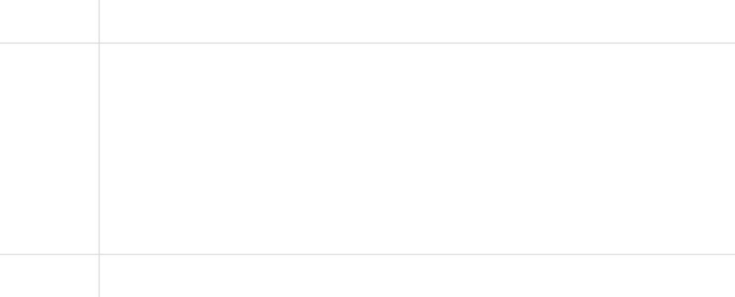

* Launch the app

|  |  |
| --- | --- |
| 2 | Sign up as a customer |
|  |  |
| 3 | Select an item and proceed to checkout |
|  |  |
| 4 | Fill in all necessary details |
|  |  |
| 5 | Click on payment field |
|  |  |

|  |  |  |
| --- | --- | --- |
|  | **Results** |  |
|  |  |  |
| Actual | No field to input credit card details on during check out |  |
|  |  |
|  |  |
| Expected | Payment field is available for card details input |  |
|  |  |
|  |  |
|  | **Additional information** |  |
|  |  |  |



|  |  |  |
| --- | --- | --- |
|  |  |  |
|  |  |  |
|  |  |  |
|  |  |  |
|  |  |  |
|  |  |
|  |  |